**ASSIGNMENT : SQL FUNCTIONS**

**SUBJECT : DBMS(THEORY)**

**ROLL NO : 24BSAI29**

**SUBMITTED BY : SYED MUHAMMAD QASIM**

**SUBMITTED TO : Ms. Sana Faiz**

Mehran University of Engineering and Technology Jamshoro

**TASK A**

1. **Generating new email address:**

* **select concat(substr(ename,1,1),substr(lastname,1,3),"@gmail.com") as "Gmail" from emp;**

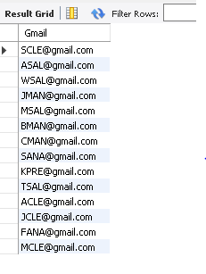

**TASK B**

* **Find the GROSS PAY of all employees using NVL2 function.**
  + **select ename,if(comm,sal+comm,sal) from emp;**

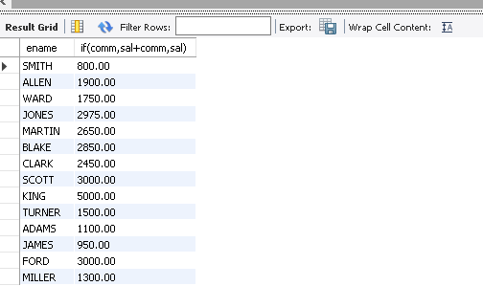

**TASK C**

1. **Using WHERE Clause for Filtering Data:**
2. **Display manger id and the salary of the lowest paid employee for that manger, exclude any those whose manger is unknown and sort the result in descending order of the lowest salary.**

* **SELECT mgr , MIN(sal) FROM emp WHERE mgr IS NOT NULL GROUP BY mgr ORDER BY lowest_salary DESC;**

1. **Display the total salary being paid to each job title within each department.**

* **SELECT deptno, job, SUM(sal) AS “total_salary” FROM emp GROUP BY deptno, job ORDER BY deptno, total_salary DESC;**

1. **Find the total annual salary distributed job wise in the year 81.**

* **SELECT job, SUM(sal * 12) AS total_annual_salary FROM emp WHERE YEAR(hiredate) = 1981 GROUP BY job ORDER BY total_annual_salary DESC;**

1. **List the Manager ids & number of employees working for those managers in the ascending order**

* **SELECT mgr AS manager_id, COUNT(empno) FROM emp GROUP BY mgr ORDER BY COUNT(empno) ASC;**

1. **Find the number of employees who are serving as CLERK?**

**select count(empno) from emp where job = "CLERK";**

1. **Find the total salary given to the MANAGERS?**

* **select sum(sal) from emp where job = "MANAGER";**

**TASK D**

**•** **List the departments where at least two employees are working**

* + **select deptno from emp Group BY deptno Having count(empno)>= 2;**

**• List the number of employees in each department where the number of employees exceeds 3.**

* + **select deptno,count(empno) from emp Group By deptno Having count(empno)>3;**

**• Find out the least 5 earners of the emp table.**

* + **select ename,sal from emp order by sal ASC limit 5;**

